FIELD MANUAL: Deer density and impact transect survey.

OVERVIEW
To provide a relative measure of deer density and their impact on vegetation, pellet counts and browsing damage surveys will be conducted along established transect lines within the site. Each 150m transact has 30 plots points at 5m intervals (Figure 1). Thirty points (red circles) will be surveyed for faecal pellets and 15 plots (green circles) will be surveyed for browsing damage. Signs of deer activity will also be recorded opportunistically, along a 20m wide belt centred on the 150m transect line (Figure 1).
A minimum of three people is required to conduct each transect survey. Ideally, one person enters data while a second person measures and identifies scats and vegetation. The third person can help the second, while also carrying out opportunistic data collection within the 20x150m transect area.

Surveys should be repeated every 12 months, during or just after the rut of the most prominent species.

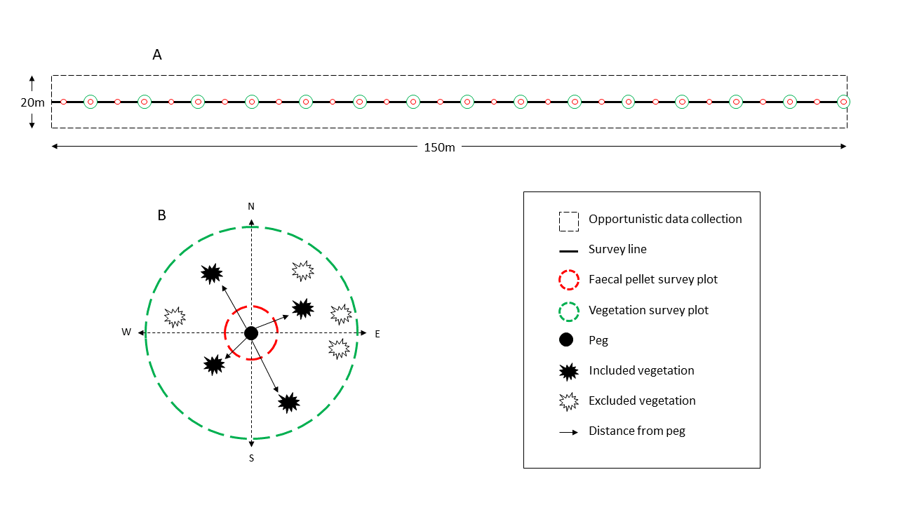
Figure 1. Schematic of field survey protocol.
A: Layout of the 150-m transect along which 30 plots are surveyed for faecal pellets (red circles) and 15 plots are surveyed for vegetation impacts (green circles). Deer signs and sapling recruitment are recorded along a 20m wide belt centred on the 150m transect line. B: Faecal pellets are counted within 1m radius circular plots at 5m intervals (red circle) along the transect. Vegetation impact assessments are conducted within 5m radius circular plots at 10m intervals (green circles).

PREPARATION
EQUIPMENT REQUIRED
- Data sheets, field method, clipboard, pencils
- Retractable builders tape measure
- Assembled survey pegs (consists of 2 large plastic sand pegs and 5m of non-stretch cord)
- Field tape

PREPARATIONS
- All participants download an app that gives GPS coordinates
- All participants are familiarised with the method
- People may want to bring food and water along

SITE SELECTION

Choose a site that is known to be regularly visited by feral deer and has evidence of damage. The site should have dense vegetation but be open enough that people can walk through.

Prior to undergoing field monitoring, establish the rough location of the transect lines within the site. Select transect lines that will be relatively easy to navigate through the vegetation and terrain. Each transect line should be at least 50m apart to reduce overlap.

METHOD

SETTING UP AND OVERVIEW

On the first survey the transect/plot pegs will be placed along the transect at the same time as the survey is conducted. If your survey plot contains an object or obstacle e.g., tree or log, survey the available area of the plot, do not move the plot. Future surveys will follow the transect line/pegs established during the first survey.

- Push one peg into the ground at the start location, but do not survey at this location. Record the latitude and longitude of the start peg.
- Use a compass to determine the direction of the transect bearing (record). Walk along the bearing in as straight a line as possible, extending the cord attached to the pegs until it is taught, 5m from start location.
- Push the second peg firmly into the ground. This is the first survey plot peg. Record the latitude and longitude. Mark the peg with the survey point number using marker pen or an aluminium plant tag. Remove the starting point peg.
- Conduct a faecal pellet count at this point (see below)
- Repeat step 2.
- At the plot peg conduct a faecal pellet count, a vegetation assessment (see below).
- Repeat procedure at 5m intervals along the same bearing until 30 survey plot pegs have been established.

SURVEY PLOT DATA COLLECTION

Faecal pellet counts
Faecal pellet counts will occur every 5m along the transect

- Run the tape 1m from the survey peg in the ground and use to determine the faecal pellet plot boundary (r=1m).
- Systematically survey the 1m radius plot for deer faecal pellets, following the rules for inclusion (Box 1). Record the number of deer pellet groups and the total number of pellets.
- Systematically survey the 1m radius plot for faecal pellets of herbivores other than deer, following the rules for inclusion (Box 1), and record the number of pellet groups belonging to other herbivores and the total number of pellets.
BOX 1: FAECAL PELLET RULES
- A pellet group is a group of pellets that appear to have been defaecated at the same time. A pellet group must contain at least 1 pellet (≥1).
- Pellets in the same group may be clumped tightly together and or spread slightly apart.
- When searching for pellets, brush aside low vegetation such as ferns, but do not disturb the leaf litter unless a pellet group is partially obscured.
- Only count pellets that are mostly intact, regardless of whether they are covered in moss or fungi. Do not count pellets that are largely disintegrated (see reference images).
- If a pellet group is found in a clump, tease apart the individual pellets using a stick to allow the number of pellets to be counted and recorded.

Vegetation assessments
Assessments will be taken every 10m along the transect.

- Run the tape 5m from the survey peg in the ground and use to determine the browsing damage plot boundary (r=1m).
- Using the digital compass, determine the location of four segments (1=NE=1–90°; 2=SE=91–180°; 3=SW=181–270°; 4=NW=271–360°). See Figure 1.
- In each segment, select the closest tree or woody shrub species to the survey plot peg, following the rules for inclusion (Box 2). If there are no trees or woody shrubs in that segment record “no plant”.

BOX 2: VEGETATION INCLUSION RULES
- The plant is a tree or woody shrub species
- The plant is greater than 10cm in height
- Choose the closest plant in each segment
- Record the following information for each plant:
  - Height in cm of the plant
  - Species of the plant, if known
  - Score of browsing damage (see table 1)

- Within the 1m radius plot, count the total number of seedlings emerging (plants under 10cm)

- Within the 1m radius plot count the total number of trees with evidence of antler rubbing. For each tree record:
  - Height of the tree (cm)
  - Percentage circumference rubbed
  - Species of plant (if known)

Table 1: Browsing damage score

Score | Description
0 | No impact | NA
1 | Low impact | 1–25% foliage browsed
2 | Low–moderate impact | 25–50% foliage browsed, stem breakage or rubbing damage
3 | Moderate–high impact | 51–75% foliage browsed, multiple stem breakage or severe rubbing damage
4 | High impact | 76–100% foliage browsed or extreme rubbing damage

OPPORTUNISTIC DATA COLLECTION

Evidence of deer signs (opportunistic/non-systematic search for deer signs)
As the survey is being conducted, take note of deer signs (see reference images) within a 20-m belt transect (10-m either side of transect line; Figure 1A) and record.
Deer signs include:
- Deer faecal pellets (not located in survey plots)
- Tracks (hoof-prints) and/or pugging (deep hoof-prints in mud)
- Wallowing
- Ring barking
- Ground scrapes made by antlers (generally near ring barked shrubs)

