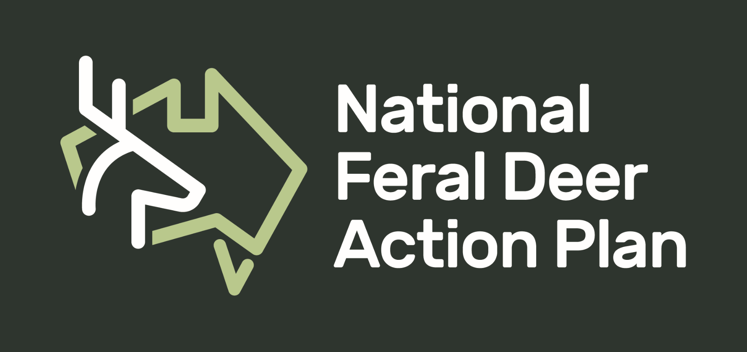

Survey on Vegetation Monitoring
to Inform Management of Feral Deer

To help facilitate the development of standardised cost-effective vegetation monitoring metrics please tell us about your project and your experiences.

Describe the deer problem in the area you are working in. (2 sentences)

Where is your program being undertaken?

Tell us about the aim and purpose of your vegetation monitoring program, and how it relates to the impacts of feral deer on native vegetation. (1 paragraph)

Summarise the vegetation metrics you are using, the frequency of sampling, and the expected duration of your monitoring program. (1 paragraph)

Which species of flora are you measuring, if applicable?

How many person hours are required to collect the monitoring data each year, or over another specified period?

Tell us what has worked well in your vegetation monitoring program. (1-3 sentences)

Tell us what has not worked well in your vegetation monitoring program. (1-3 sentences)

What do you wish you could have done to make the program better? (1-3 sentences)

Would you like to have your story shared in our monthly Newsletter?
If yes, please include a photo that we can include on the Newsletter. Who should we source for this photo?

Would you be interested in attending or presenting in a national online forum (1.5 hr) on monitoring the impact that feral deer have on the environment? (if so, please provide your email address so we can provide you with future details).

Please return to coordinator@feraldeerplan.org.au.

If you have any questions, please don’t hesitate to contact Shannon Evenden (National Feral Deer Support Officer) through an email (address above) or call 0478745161.

