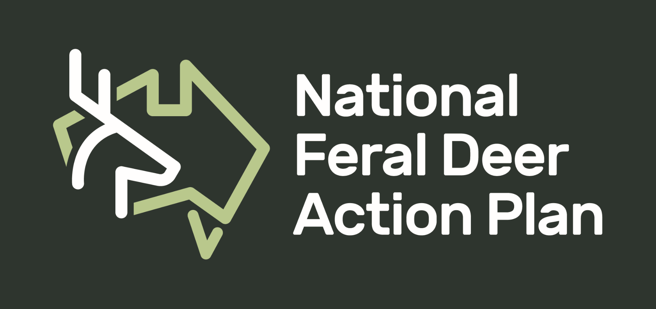
Tell us how feral deer have impacted you.
We want to share your experience with feral deer. Your experience can be regarding impacts to regeneration attempts, observed threat to native flora and/or fauna, impacts to agriculture, experience with road safety, and anything else that is relevant.

Please tell us about yourself and where you live.

What is your story about? Pick one.
- Regeneration attempts
- Native flora and/or fauna
- Agriculture
- Road safety
- Other (please specify)

Tell us about your experience (maximum of 400 words).

Would you like to have your story shared in our monthly Newsletter?
If yes, please include a photo that we can include on the Newsletter. Who should we source for this photo?

Please return to coordinator@feraldeerplan.org.au.
If you have any questions, please don’t hesitate to contact Shannon Evenden (National Feral Deer Support Officer) through an email (address above) or call 0478745161.

