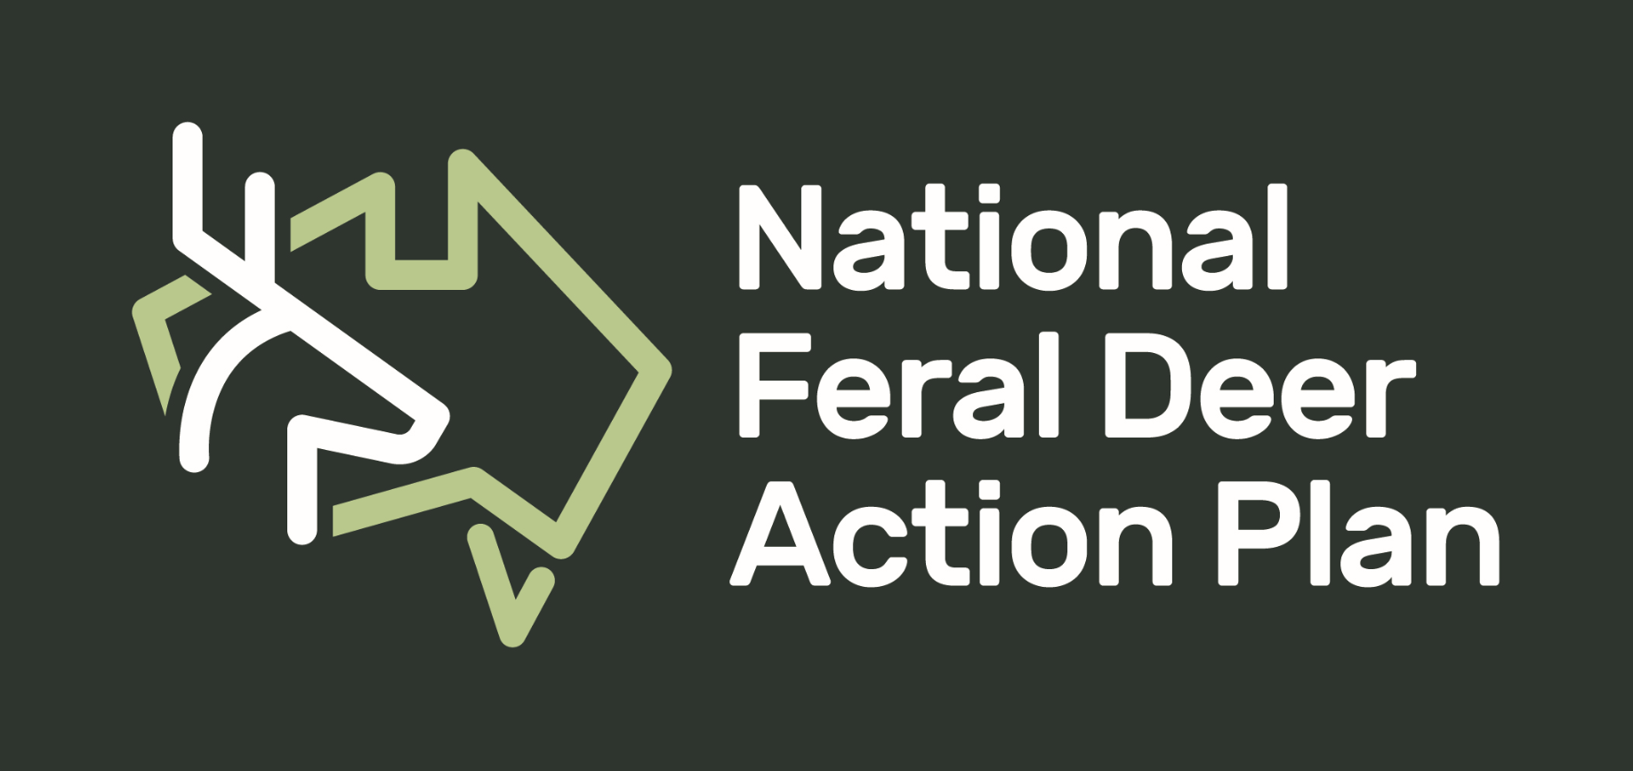

Survey on Feral Deer Programs and Groups Involved in Feral Deer Control/Monitoring.

This survey is to collate information on feral deer control programs around Australia, to enable groups to network, contact and collaborate with each other on issues of feral deer control.

Please return the survey to Shannon Evenden at coordinator@feraldeerplan.org.au.
If you have any questions, please don’t hesitate to ask either by email (above) or mobile (0478745161)

What is the name of your group? and what is your email address (for the National Feral Deer Project to contact you in the future)?

Where is your project undertaken?

Tell us about your group in 200-400 words
- What is your group focus (mostly deer control/mostly herbivore control/general pest control/all land management activities)?
- Describe the deer problem in the area you are working in.
- What type of land are you working with (private land/public land/mix)?
- What type of funding (if any) do you receive (commonwealth, State, private)?

What is your reason for having a deer control program?
- Primary production
- Conservation
- Road safety
- Other (please specify)

Which category best describes your group?
- Indigenous group
- Hunting organisation
- State government
- Local government
- Industry
- Landholder group
- Federal government
- Research
- Conservation and biodiversity

Does your program have a website or other digital link that you would like to be shared? If so, please provide details.

What contact details would you provide to others wishing to discuss control of feral deer?

