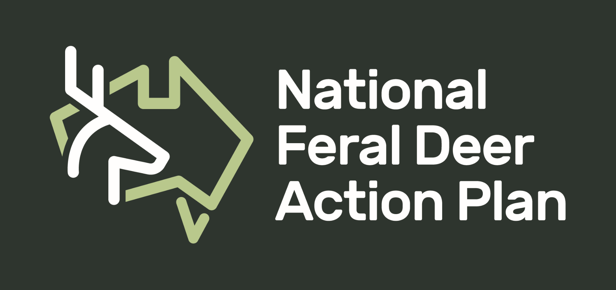
CASE STUDY OF FERAL DEER MONITORING/CONTROL PROGRAM
The aim of these case-studies is to encourage collaboration and increase knowledge sharing between groups around the country.

Who is your group?
- What is your “title”
- Government/ LLS/ Landholders / Researchers/ Industry

Where is your program being undertaken?

In a sentence, what is the aim of your campaign/project?

Describe the deer problem in the area you are working in.

What projects have you and your group been involved in so far?
- Describe the project.
- Why did you choose certain control methods?
- What worked well?
- What didn’t work well?
- What advice would you give to others?

What plans do you / does your group have for the future?

Would you be interested in attending or presenting in a national online forum (1.5 hr) on how to control feral deer in Australia? (if so, please provide your email address so we can provide you with future details).

Would you like to have your story shared in our monthly Newsletter?
If yes, please include a photo that we can include on the Newsletter. Who should we source for this photo?

Please return to coordinator@feraldeerplan.org.au.
If you have any questions, please don’t hesitate to contact Shannon Evenden (National Feral Deer Support Officer) through an email (address above) or call 0478745161.

